PRACTICAL- 5

Problem Definition
Create a student registration form with HTML5 input types and JavaScript
validation for name, email, mobile number, password, confirm password,
course, year, gender, and terms acceptance. Use Regular Expression for
validations.

1. Are correct input types and attributes used?
Yes. Appropriate HTML5 input types and attributes are used to collect valid and required user information.

2. Are validation errors displayed near the relevant fields?
Yes. Validation errors should be displayed near the field where the user entered incorrect or invalid data.

3. Is password strength checked?
Yes. JavaScript can check the password strength based on conditions such as length and required characters.
4. Is the form accessible using keyboard and screen-reader-friendly
labels?
Yes. Proper labels and accessible form elements are used so the form can be easily used with a keyboard and screen readers.

SCREENSHOT:
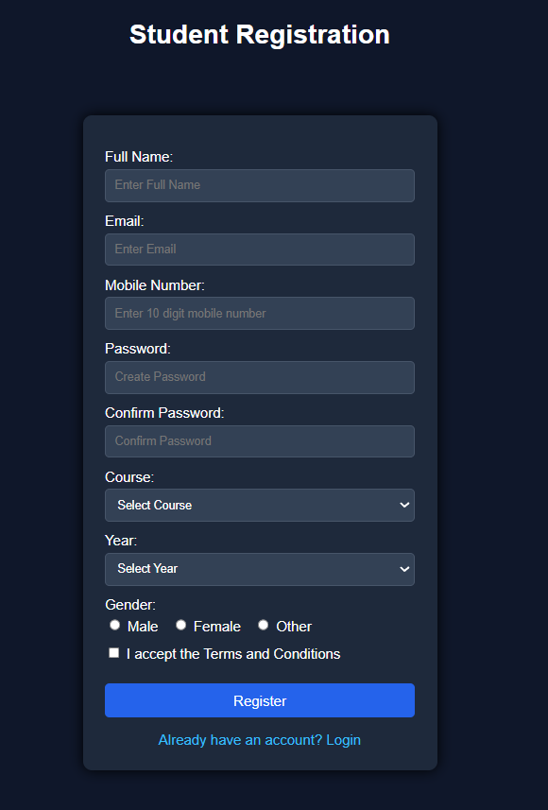

Implementation
● Created a student registration form using HTML5.
● Implemented JavaScript validation for name, email, mobile number, and password.
● Added validation for confirm password and other required fields.
● Used Regular Expressions for input validation.
● Added user-friendly error messages for invalid inputs.
● Implemented password strength checking.
● Used proper labels and input types for accessibility.
Challenges
● Handling different types of invalid user inputs.
● Writing correct validation conditions and Regular Expressions.
● Displaying error messages near the relevant fields.
● Checking password strength and confirm password correctly.
● Making the form accessible and user-friendly.
● Handling all required fields properly.
GitHub Repository
Link: https://github.com/dharmkakasaniya01/Student
Conclusion :

The student registration form was successfully created with proper JavaScript validation. User inputs were checked for correctness, invalid data was handled with clear error messages, and the form was made more accessible and user-friendly.

